OUTPUT
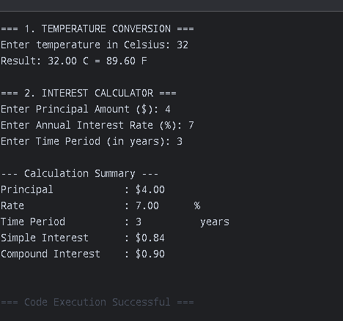

#include <stdio.h>
#include <math.h>

int main() {
// --- Program 1: Temperature Conversion (float) ---
float celsius, fahrenheit;

printf("=== 1. TEMPERATURE CONVERSION ===\n");
printf("Enter temperature in Celsius: ");
scanf("%f", &celsius);

// Arithmetic calculation using float operators
fahrenheit = (celsius * 9.0 / 5.0) + 32.0;

// Formatted output limited to 2 decimal places
printf("Result: %.2f C = %.2f F\n\n", celsius, fahrenheit);

// --- Program 2: Simple & Compound Interest (double & int) ---
double principal, rate, simpleInterest, compoundInterest;
int timePeriod;

printf("=== 2. INTEREST CALCULATOR ===\n");
printf("Enter Principal Amount ($): ");
scanf("%lf", &principal);

printf("Enter Annual Interest Rate (%%): ");
scanf("%lf", &rate);

printf("Enter Time Period (in years): ");
scanf("%d", &timePeriod);

// Simple Interest Formula: SI = (P * R * T) / 100
simpleInterest = (principal * rate * timePeriod) / 100.0;

// Compound Interest Formula: CI = P * ((1 + R/100)^T) - P
compoundInterest = principal * pow((1.0 + rate / 100.0), timePeriod) - principal;

// Formatted tabular output
printf("\n--- Calculation Summary ---\n");
printf("%-20s : $%-10.2lf\n", "Principal", principal);
printf("%-20s : %-10.2lf%%\n", "Rate", rate);
printf("%-20s : %-10d years\n", "Time Period", timePeriod);
printf("%-20s : $%-10.2lf\n", "Simple Interest", simpleInterest);
printf("%-20s : $%-10.2lf\n", "Compound Interest", compoundInterest);

return 0;
}

